|  |
| --- |
| **BAHRIA UNIVERSITY (KARACHI CAMPUS)**    **MIDTERM ASSESSMENT – SPRING 2020 Digital Design (CEN- 122)**      Class: **BSE-2A & 2B** Max Marks: **20**  Faculty Member: **Engr. Mahawish** Due Date: **31st May 2020**    Student’s Name: _AHMED FARAZ______ Reg. #: __02-131192-037___    Note:   * All questions should be answered in the same file using black font color. * Write the answer in your own wordings and avoid copying/pasting. * Your submitted report might be checked for plagiarism. |

# Q: 1 [2.0 Marks] [CLO 2]

Encode the expression **“my name is ____.”** (e.g., my name is Sana) in ASCII using an eight-bit code also include the period and space.

**Answer:**

Expression:

“my name is Ahmed Faraz”

ASCII:

341091213211097109103321051153265104109991003270971149712234

Code using 8-bit:

0010001001101101011110010010000001101110011000010110110101100101001000000110100101111001100100000010000010110100001101101011001110110010000100000010001100110000101110010011000010111101000100010

# Q: 2 [2.0 Marks] [CLO 2]

Perform the subtraction with the following unsigned decimal numbers by taking the 10's complement of the subtrahend.

1. 5250 - 1321 **(0.5)**

Solution:

Subtrahend = 1321

Taking 9’s complement

9999

-1321

8678

Taking 10’s complement

8678

+1

8679

Now Adding,

5250

+8679

1|3929

Final Answer = 3929

Verification:

5250

-1321

3929

1. 1753 - 8640 **(0.5)**

Solution:

Subtrahend = 8640

Taking 9’s complement

9999

-8640

1359

Taking 10’s complement

1359

+1

1360

Now Adding,

1753

+1360

3113

Introducing -ve sign by taking 10’s complement of 3113

Taking 9’s complement

9999

-3113

6886

Taking 10’s complement

6886

+1

6887

Final Answer = 6887

Verification:

1753

-8640

-6887

1. 20 - 10 **(0.5)**

Solution:

Subtrahend = 10

Taking 9’s complement

99

-10

89

Taking 10’s complement

89

+1

90

Now Adding,

90

+20

1|10

Final Answer = 10

Verification:

20

-10

10

1. 1200 – 250 **(0.5)**

Solution:

Subtrahend = 250

Taking 9’s complement

999

-250

749

Taking 10’s complement

749

+1

750

Now Adding,

1200

+750

1|950

Final Answer = 950

Verification:

1200

-250

950

# Q: 3 [4.0 Marks] [CLO 2]

Determine the SOP and POS expressions for the following function and also draw the circuit diagram.

**F (x1, x2, x3, x4) = Σm(1, 3, 5, 7, 9, 11, 15) + d(2, 4, 12, 14)**

**Answer:**

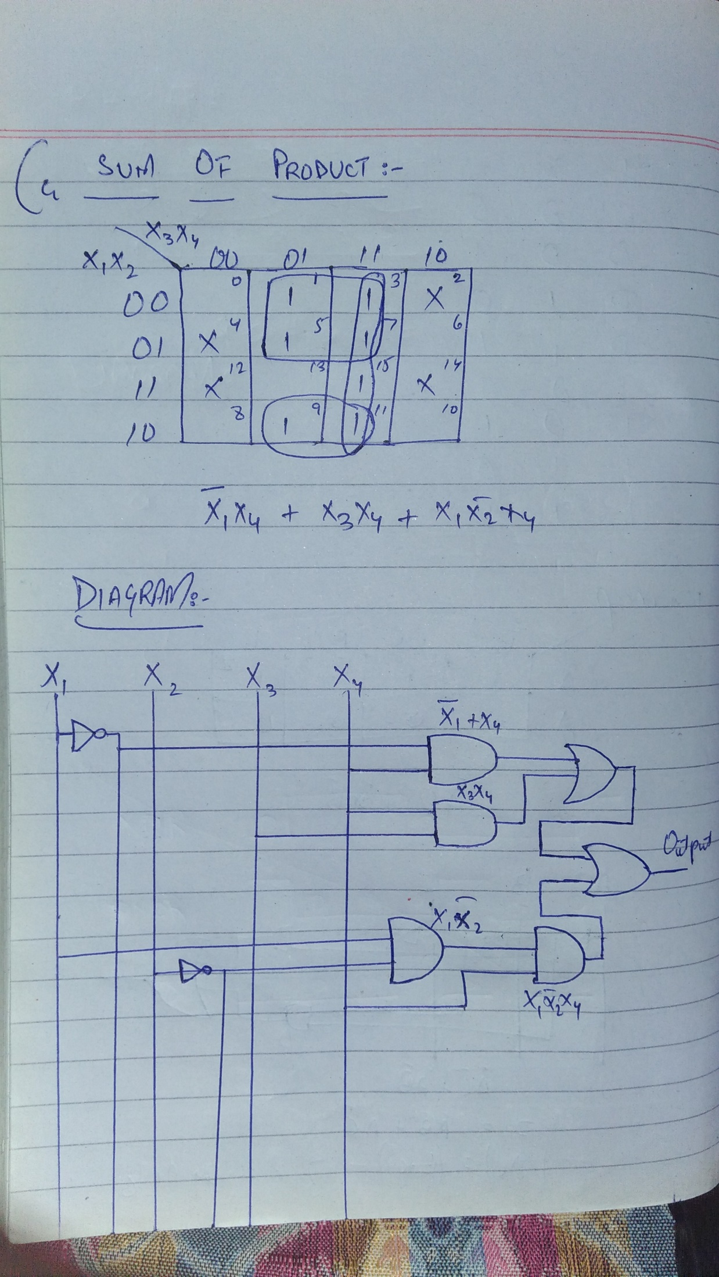

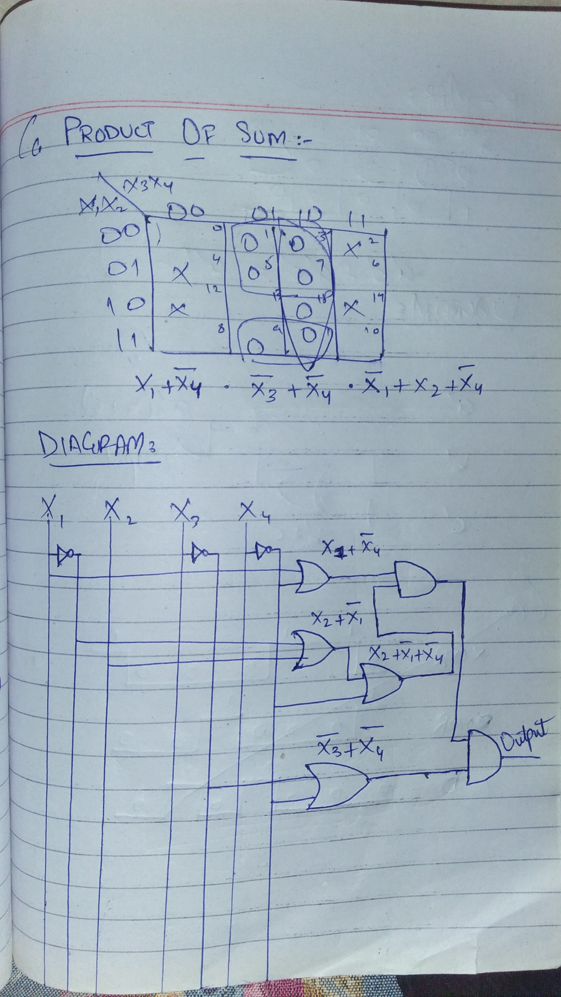

# Q: 4 [8.0 Marks] [CLO 2]

Minimize the following Boolean expression using Boolean laws also write the name of Boolean identities in minimize each step.

1. **A.B (A+B) (1+B’) (2.0)**

AAB +ABB(1+B’) Idempotent law

AB+AB (1+B’) Idempotent law

AB(1+B’)

AB+ABB’ Inverse law

AB Final Answer

1. **(1 + C) (A.D + A.D’) + A.C + C (2.0)**

(A.D + A.D’) + A.C + C Null law

A1+A.C+C Inverse law

A+A.C+C

A(1+C)+C Null law

A+C Final Answer

1. **(A.C) + (B.C’) (2.0)**

Solution not possible

1. **((A.B)+A).((B.B)+B’)) (2.0)**

A(B+1) (B+B’) Null law

A Inverse law

# Q: 5 [2.0 Marks] [CLO 3]

Design a combinational circuit with three inputs and one output. The output is 1 when the binary value of the inputs is less than 3. The output is 0 otherwise.

Truth Table:

|  |  |  |  |
| --- | --- | --- | --- |
| a | b | c | d |
| 0 | 0 | 0 | 1 |
| 0 | 0 | 1 | 1 |
| 0 | 1 | 0 | 1 |
| 0 | 1 | 1 | 0 |
| 1 | 0 | 0 | 0 |
| 1 | 0 | 1 | 0 |
| 1 | 1 | 0 | 0 |
| 1 | 1 | 1 | 0 |

K-Map and Circuit Diagram:

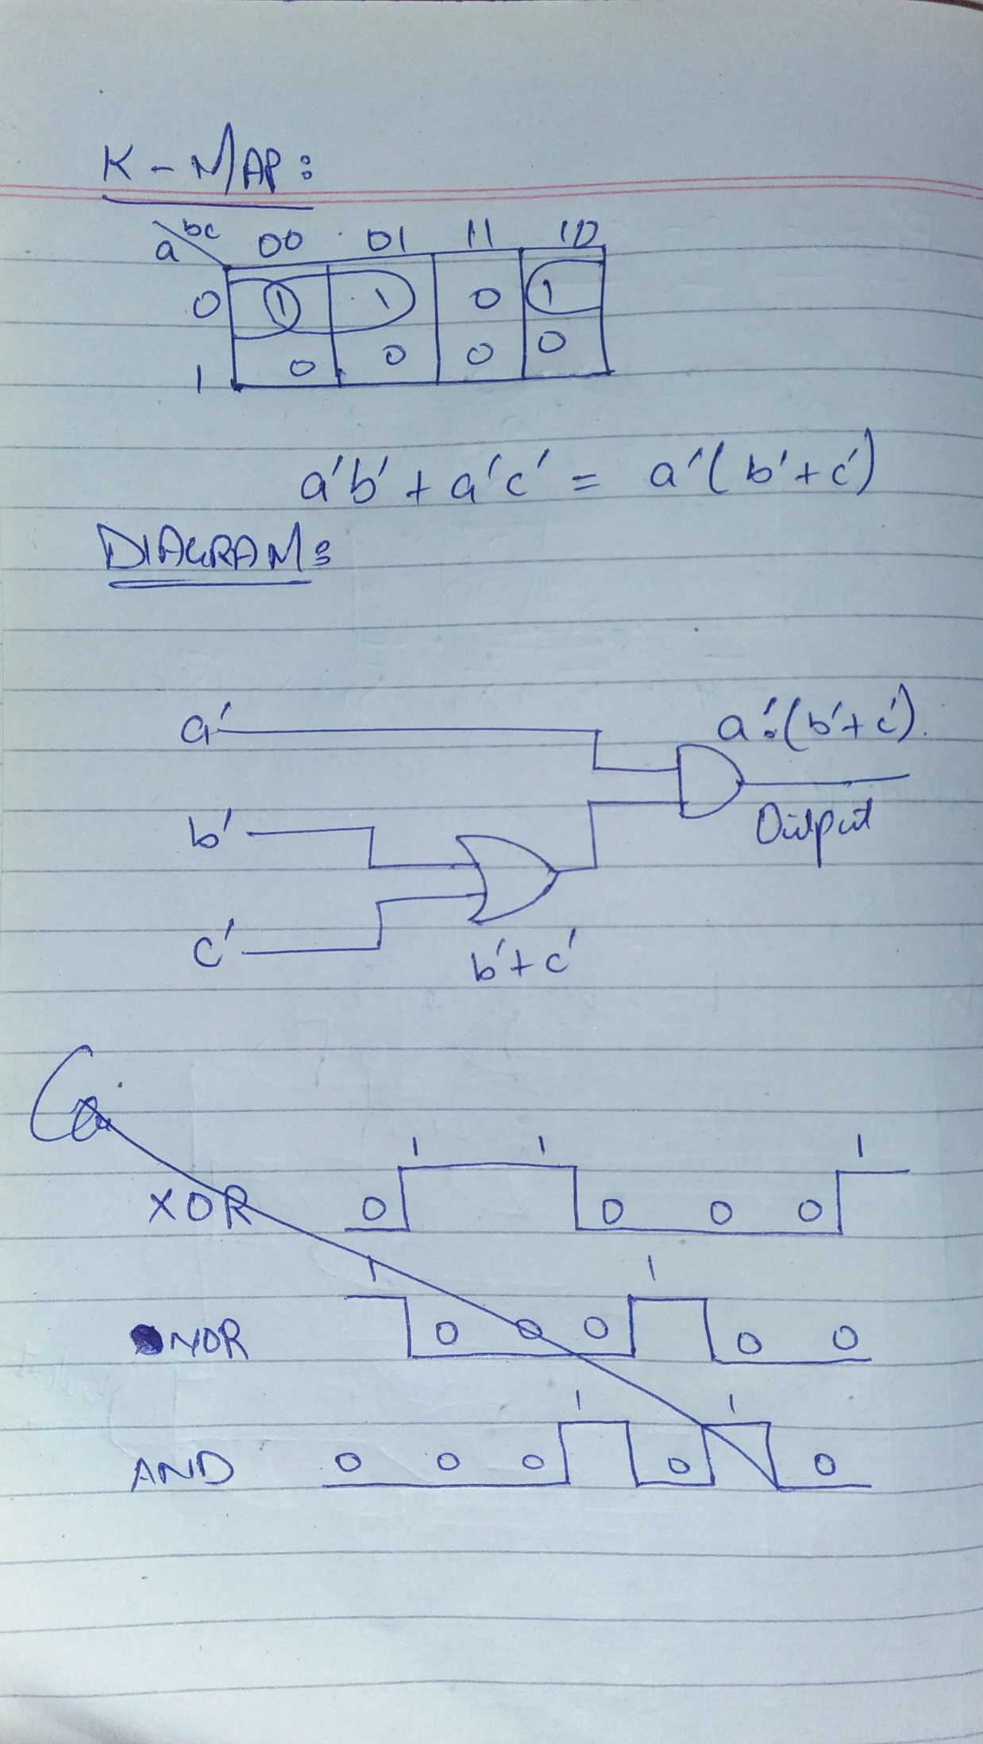

# Q6: [2.0 Marks] [CLO 3]

Design the output waveform for **XNOR**, **AND**, **NOR** and **XOR** logic gates the two inputs A and B are given below.

Page 1 of 2

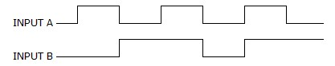

Answer:

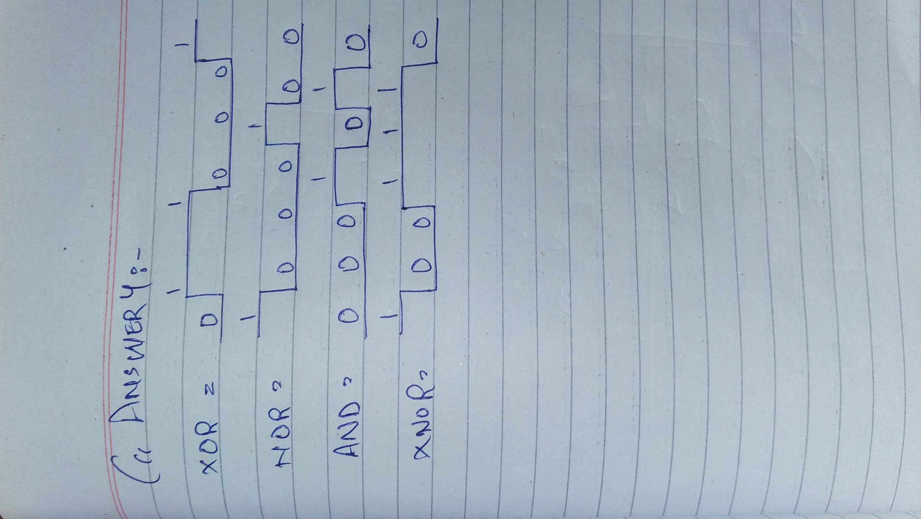

Good Luck

Page 2 of 2